LEMKEN France moves into new premises

More space for sales and service

LEMKEN, the specialist for agricultural technology, invested in a new sales and service site in Boigny-sur-Bionne near Orleans. France is LEMKEN’s most significant market after Germany. The company’s largest subsidiary therefore now not only has a prestigious location, but also more opportunities to present LEMKEN’s comprehensive range of products to local sales partners and farmers and to conduct training events.

LEMKEN invested a total of EUR4.5 million in this sales and service office. The customer and spare parts service aspect has been considerably expanded with 1,100 m² of warehousing space and an own workshop, enabling to serve end customers even better and more quickly. With over 1,300 m², the AgroForum, a large exhibition hall, offers plenty of space for demonstrations and events. AgroTraining additionally has a 400 m² hall and four training rooms to be able to familiarise sales partners and customers with the handling and practical application of our technology. Participants in training events can then apply their new knowledge directly on 4.4 hectares of arable land and try out our implements in field use.

A two-storey office building offers plenty of space not only for the team of 43 employees, but also for the future growth of the French sales organisation. Last year alone, the team around managing director Jean-Christophe Regnier grew by four new people. With its new office, LEMKEN has created optimal conditions for continuing to expand its market position in France.

***

LEMKEN, a specialist for professional arable farming with annual sales of EUR325 million, and a global company employing more than 1,400 staff, is one of Europe’s leading suppliers. Founded as a blacksmith’s shop in 1780, this family-operated company produces high-quality, high-performance agricultural implements for soil cultivation, seeding and plant protection in Germany at its headquarters in Alpen and its plant in Haren as well as in Nagpur/India. Innovation in the best interest of our customers guides our thoughts and actions. For additional information on LEMKEN please visit our homepage at www.lemken.com.

Press Contact

Marie Ehses
Phone +49 2802 81 - 250
Fax +49 2802 81 - 262
www.lemken.com
m.ehses@lemken.com

Image 1: The new site of LEMKEN France
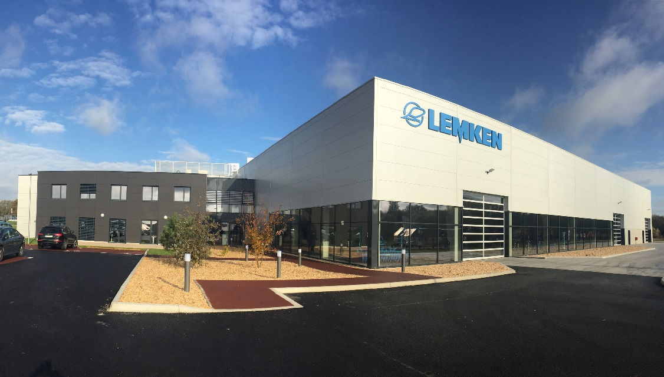

Image 2: The new site of LEMKEN France
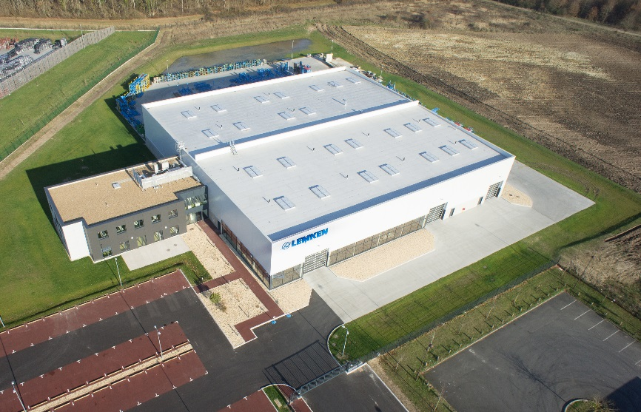

Image 2: The new site of LEMKEN France
