LEMKEN's solid track record

The specialist agricultural technology manufacturer has made the best use of 2020

LEMKEN, the specialist for professional crop production, ended the past financial year with sales at an almost unchanged high level of EUR365 million. Demand was particularly high for seed drills and hoeing technology. The new year has also started well with very good levels of incoming orders.

Antony van der Ley summarised the past year by saying, "We are happy and grateful that we were able to maintain our production throughout the past year without placing the health of our 1,631 employees worldwide at risk. We have achieved our ambitious goals for both sales and results and are very satisfied, even though we exited the field sprayer sector. We have also been able to bolster our service for specialist dealers, farmers and contractors at the highest level. We managed the challenges of COVID well by providing many smaller-scale demonstrations and digital offerings. However, we would certainly be delighted if we were able to have face-to-face contacts and events again soon so that we can demonstrate the benefits of our methods on the fields for everybody to see."

Last year LEMKEN, the AgroVision Company, took a clear decision on its future direction by stopping field sprayer production and focusing its strengths fully on the manufacture of modern precision hoeing technology. This has already yielded initial success: LEMKEN's subsidiary Steketee has distinguished itself as an innovation factory and increased its sales by 30 percent. Its product portfolio includes customisable hoeing machines, which support highly economical weed control thanks to camera-controlled individual plant detection. The new fertiliser spreaders, which LEMKEN offers in a wide range of models to service very diverse operating conditions, have also been established successfully on the market.

Sales in the German home market have remained consistently high, although international sales dominate with a 77 percent share in total sales. In 2020, the company's largest markets included France, Russia, the USA and the United Kingdom, with substantial increases in sales for the last three of these countries.

The family-run business is very optimistic for the current year of 2021, given the high levels of incoming orders. In view of the high growth expectations, LEMKEN invested in state-of-the-art assembly processes in the company's Haren factory, which has been completely set up for the manufacture of seed drill technology since the beginning of the year. New market offerings include the hybrid cultivator Koralin 9 for ultra-shallow tillage, the compact cultivator Kristall for working widths of up to 10 metres and the new OptiStone overload protection for ploughs. In the seed drill segment, LEMKEN has started manufacturing the updated, new Saphir and Solitair models, including a double tank/hopper (for more seeds or fertiliser), the Solitair 23 front tank with ISOBUS control and the 6 metre-wide Solo seed coulter bar with independent chassis. Among new products to be introduced are a large-scale seed drill and extended precision drilling technology with the Azurit and its innovative DeltaRow technology. LEMKEN is additionally firmly committed to digitalisation and networking, offering solutions for precise field work and smart data management. The iQblue connect system, which has been awarded by the German Agricultural Society (DLG), will be the first accessory system on offer that intelligently automates the operating functions of tillage implements via the tractor controls.

***
About LEMKEN: LEMKEN enjoys a worldwide reputation as a visionary, sustainably operating company that makes an important contribution to profitable agriculture. A medium-sized German family company, LEMKEN has applied its expertise and passion for progress for 241 years, delivering solutions for the challenges confronting agriculture today and tomorrow. The company’s product range includes tillage implements, seed drills, hoeing machines, fertiliser spreaders and smart solutions for agricultural data management. LEMKEN currently employs 1,600 staff worldwide and has an annual turnover of about €400 million.

Press Contact

Marie Ehses
Phone +49 2802 81 - 250
m.ehses@lemken.com
www.lemken.com

Fig. 1: LEMKEN's new Koralin shallow cultivator

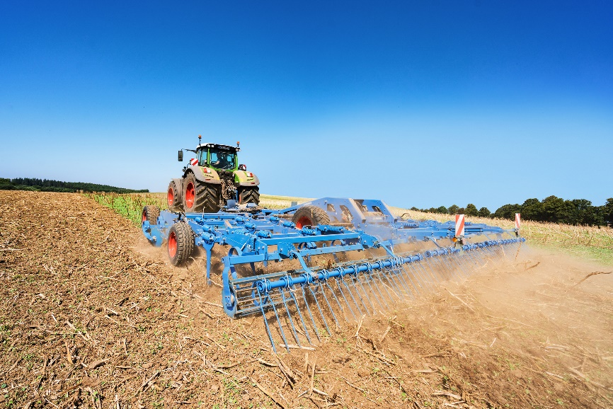

Fig. 2: The Juwel 10 mounted reversible plough with OptiStone overload protection

